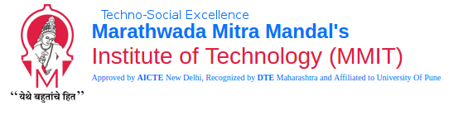

**Career Objective**: Want to work for a reputed organization in a position where innovations are always welcomed and individual’s growth is encouraged alongside organization’s growth.

|  |  |  |  |  |  |
| --- | --- | --- | --- | --- | --- |
| **ACADEMIC BACKGROUND** | | | | | |
| B.E. |  | Sem 8  Yet To Appear | Sem 7  Yet To Appear | Department of Electronics and Telecommunication Engineering  Marathwada Mitra Mandal’s Institute of Technology | 65.06% |
| T.E. | MAY  2015 | Sem 6  59.60 | Sem 5  62.4 |
| S.E. | MAY  2015 | Sem 4  63.46 | Sem 3  71.06 |
| F.E. | MAY  2015 | Sem 2  73.57 | Sem 1  60.57 |
| Class XII | MAR  2013 | H.S.C | | | 67.17% |
| Class X | MAR  2011 | C.B.S.E | | | 74.80% |
| **ACADEMIC ACHIEVEMENTS** | | | | | |
| * Secured **Topper** position in E&TC Dept. in 2nd Year of Engineering. | | | | | |
| **CERTIFICATIONS** | | | | | |
| * Attended hands on training program on **‘Advanced Embedded Technology-Raspberry Pi’.** * Participated in ‘**PLC and SCADA automation workshop’.** | | | | | |
| **PROJECTS** | | | | | |
| * Digital Notice Board with Voice Notification. | | | | | |
| **EXTRA CURRICULAR ACTIVITIES** | | | | | |
| * Volunteered for **National Level Technical Symposium - Samvitti 2k16** * Participated in Football events in **ZEST’15 and ZEST’16** organised by College of Engineering, **PACE 2016** organised by Army Institute of Technology, **National Level Inter-Engineering** football event – **ONYX’15** organised by MIT Academy of Engineering Alandi, **M.M KARANDAK’15** organised by Marathwada Mitramandal College of Engineering, Pune. * Participated in Street Play events in **MELANGE’16** organised by Vishwakarma Institute of Technology, **JISHIN’16** organised by Bharati Vidyapeeth’s College of Engineering for Woman, **GANDHAAR’16** organised by Cummin’s College of Engineering for Woman, **INNOVISION’16** organised by JSPM Group of Institutes, Pune. * Participated in Computer Gaming and Contraption events in **SPECTRUM’14** organised by Pimpri Chinchwad College of Engineering, Pune. | | | | | |
| **ADDITIONAL INFORMATION** | | | | | |
| * **Preferred Programming Language** : C * **Preferred Technologies** : Automation * **Familiar with** : HTML * **Hobbies : Rapping, Music Production, Song Writing and Composition** | | | | | |

**Declaration** : I hereby declare that information furnished above is true and correct to my knowledge.

Place : Signature